- Literature Review
Breast cancer detection has been widely explored using medical data and different classification techniques. Since early diagnosis is crucial for successful treatment and better survival rates, many researchers have focused on building models that can distinguish between benign and malignant cases. This chapter reviews key studies on breast cancer detection and summarizes their main findings.

2.1 Overview of Breast Cancer Detection
Breast cancer develops when abnormal cells in the breast grow and divide uncontrollably. Detecting it early greatly increases the chances of effective treatment. In many research works, medical datasets are used that include features such as cell size, shape, and texture. Classification techniques are then applied to these datasets to predict whether a tumor is benign or malignant.

2.2 Classification Methods Used in Literature

2.2.1 Decision Tree
Decision Tree is one of the most commonly used classification methods in medical data analysis. It works by splitting the dataset into smaller groups based on feature values, forming a tree-like structure of decisions.
Many studies use Decision Trees because they are simple to understand and easy to interpret. However, they can easily overfit the training data, which often leads to lower accuracy when tested on new, unseen data.

2.2.2 Random Forest
Random Forest is an ensemble technique that combines many Decision Trees to improve prediction performance. It has been applied widely in breast cancer detection.
Research shows that Random Forest generally achieves higher accuracy and better generalization than a single Decision Tree. By averaging the results of multiple trees, it reduces overfitting and tends to be more robust, especially with larger datasets.

2.2.3 Support Vector Machine (SVM)
Support Vector Machine is another widely used classification method in cancer detection studies. It works by finding an optimal boundary that separates different classes in the data.
Studies report that SVM performs particularly well on high-dimensional datasets and can achieve good classification accuracy. However, its performance depends heavily on selecting suitable parameters and kernel functions.

2.3 Review of Existing Research Work
A large number of researchers have compared different classification methods for breast cancer detection.
- Abien Fred Agarap (2017) applied multiple classification techniques on the Wisconsin Breast Cancer Dataset (WBCD) and reported accuracies above 90% for most models, with neural networks achieving very high accuracy.
- Studies by Akash Rajak et al. (2018), Kumar et al. (2021), Gupta et al. (2024), and others show that Random Forest often performs better than Decision Tree and SVM in terms of accuracy and stability when using WBCD.
- Research by authors such as Alka Jain (2020) and Reddy et al. (2023) highlights that SVM can perform strongly, especially when the dataset is well preprocessed and normalized.
- Other works, including those by Singh et al. (2024) and Patel et al. (2025), emphasize that feature selection and preprocessing significantly improve model performance.
- Some recent studies, such as those by Jalloul et al. (2023), indicate a growing interest in deep learning methods and hybrid approaches that combine traditional machine learning with feature selection or boosting techniques.
Overall, these studies show that while many methods achieve high accuracy on breast cancer datasets, their performance depends on factors such as the chosen algorithm, data quality, preprocessing steps, and feature selection.

2.4 Comparative Analysis of Existing Work
Table 2.1 summarizes several important studies on breast cancer detection. Most of them use the Wisconsin Breast Cancer Dataset (WBCD) as a common benchmark and apply different machine learning methods such as Decision Tree (DT), Random Forest (RF), Support Vector Machine (SVM), k-Nearest Neighbors (KNN), boosting methods, and neural networks.
In general:
- Neural network-based models (e.g., MLP) have shown very high accuracy in some studies.
- Random Forest frequently appears as one of the best-performing methods, often achieving accuracy around or above 95%.
- Simpler models like Decision Tree or KNN tend to have slightly lower accuracy but remain easier to interpret.
- Studies that combine feature selection or advanced preprocessing steps usually report improved performance.
These comparisons help researchers understand which methods are more suitable under different conditions and how design choices affect the final results.

2.5 Discussion
From the reviewed literature, Random Forest generally stands out for its strong accuracy and stability, largely because it is an ensemble of multiple trees. Support Vector Machine also performs well, especially with high-dimensional data and when parameters are carefully tuned. Decision Tree, while easier to understand and explain, usually offers lower accuracy and is more prone to overfitting.
It is also clear that preprocessing techniques and feature selection play a major role in model performance. Cleaning the data, normalizing features, and selecting the most relevant attributes often lead to better and more reliable results. Comparative studies are particularly valuable because they reveal the strengths and weaknesses of each method rather than focusing on a single technique.

2.6 Research Gap
Although extensive work has been done on breast cancer detection using classification methods, some gaps still remain:
- Many studies concentrate on a single algorithm instead of comparing multiple methods in a systematic way.
- There is often limited analysis of why performance differs between models.
- In some cases, preprocessing steps and feature selection are not explored in detail, even though they strongly influence outcomes.
- Some studies do not provide a thorough evaluation using standard metrics such as accuracy, precision, recall, and others.
These gaps show the need for more structured comparative studies that carefully examine methods, preprocessing techniques, and evaluation measures.

2.7 Conclusion
The literature review confirms that classification techniques are effective tools for breast cancer detection using medical data. However, there is still a need for systematic comparisons of different methods under the same conditions.
This project aims to address these gaps by applying multiple classification techniques—such as Decision Tree, Random Forest, and SVM—to a common dataset, using consistent preprocessing steps and standard evaluation metrics. The goal is to identify the most reliable approach for early breast cancer detection and to provide clearer insights into how different methods perform in practice.
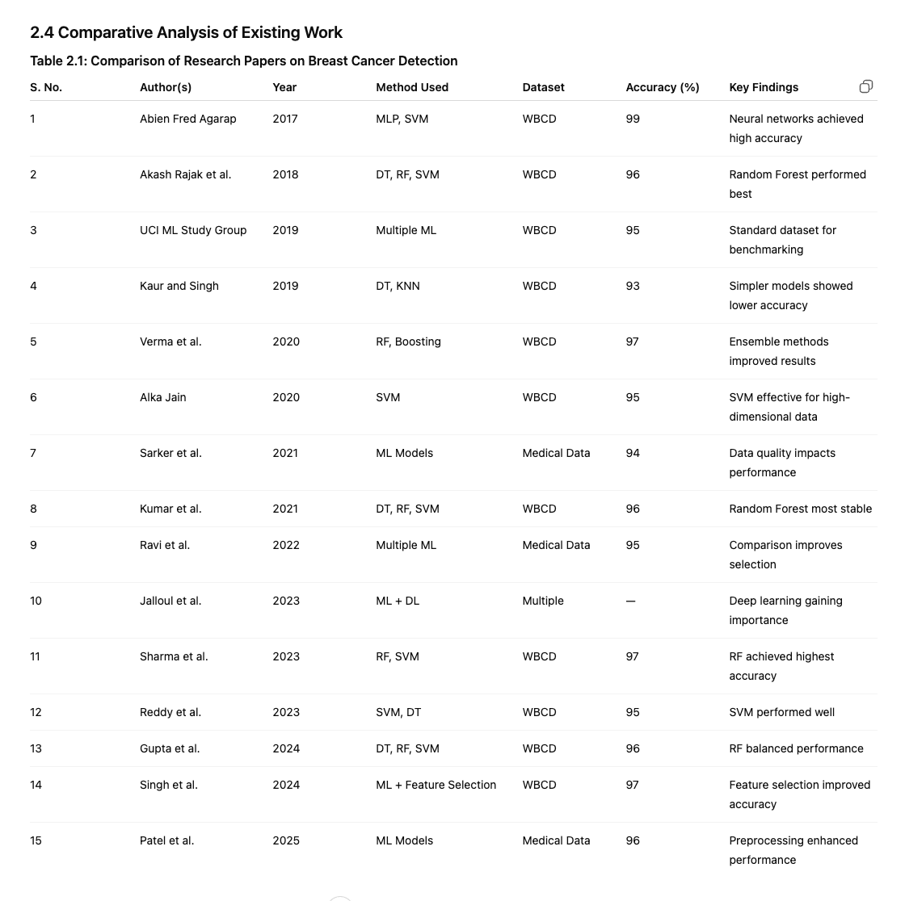

S. No. | Author(s) | Year | Methods Compared | Dataset | Key Metrics | Best Method | Remarks
1 | Abien Fred Agarap | 2017 | MLP, SVM, LR | WBCD | Accuracy | MLP (~99%) | Neural models showed highest performance
2 | Rajak et al. | 2018 | DT, RF, SVM | WBCD | Accuracy, Recall | RF (~96%) | Ensemble improved prediction
3 | UCI Study Group | 2019 | Multiple ML | WBCD | Accuracy | — | Dataset used as benchmark
4 | Kaur & Singh | 2019 | DT, KNN | WBCD | Accuracy | KNN (~93%) | Simpler models less effective
5 | Verma et al. | 2020 | RF, Boosting | WBCD | Accuracy, Precision | RF (~97%) | Ensemble methods improved results
6 | Jain | 2020 | SVM | WBCD | Accuracy | SVM (~95%) | Effective in high dimensions
7 | Sarker et al. | 2021 | ML Models | Medical Data | Accuracy | RF | Data quality impacts results
8 | Kumar et al. | 2021 | DT, RF, SVM | WBCD | Accuracy, Recall | RF (~96%) | Most stable performance
9 | Ravi et al. | 2022 | Multiple ML | Medical Data | Accuracy | RF | Comparative studies useful
10 | Jalloul et al. | 2023 | ML + DL | Multiple | — | DL Models | Shift towards deep learning
11 | Sharma et al. | 2023 | RF, SVM | WBCD | Accuracy | RF (~97%) | RF highest accuracy
12 | Reddy et al. | 2023 | SVM, DT | WBCD | Accuracy | SVM (~95%) | SVM performed better
13 | Gupta et al. | 2024 | DT, RF, SVM | WBCD | Accuracy | RF (~96%) | Balanced performance
14 | Singh et al. | 2024 | ML + Feature Selection | WBCD | Accuracy | RF (~97%) | Feature selection improved results
15 | Patel et al. | 2025 | ML Models | Medical Data | Accuracy, Recall | RF (~96%) | Preprocessing improved accuracy

2. Literature Review

2.1 Overview of Breast Cancer Detection
Breast cancer is one of the most prevalent cancers among women worldwide and remains a major public health concern. Early diagnosis plays a crucial role in reducing mortality rates and improving treatment outcomes. Recent advances in machine learning and data mining techniques have enabled researchers to develop intelligent systems capable of detecting breast cancer with high accuracy. Various classification algorithms have been applied to medical datasets containing features such as cell size, cell shape, texture, and other diagnostic attributes to distinguish between benign and malignant tumors.

2.2 Classification Methods Used in Literature

2.2.1 Decision Tree
Decision Tree is a widely used supervised learning algorithm for classification tasks in medical diagnosis. It constructs a tree-like structure where each internal node represents a decision based on an attribute, and each leaf node represents a classification outcome. Due to its simplicity and interpretability, Decision Tree has been extensively employed for breast cancer prediction. However, its performance may decrease when dealing with noisy or highly complex datasets.
Reference:
- Quinlan, J. R. (1986). Induction of Decision Trees. Machine Learning, 1(1), 81–106.

2.2.2 Random Forest
Random Forest is an ensemble learning technique that combines multiple decision trees to improve classification accuracy and reduce overfitting. It has demonstrated excellent performance in breast cancer detection by effectively handling large datasets and selecting important features. Studies have reported that Random Forest achieves higher prediction accuracy compared to individual classifiers.
References:
2. Breiman, L. (2001). Random Forests. Machine Learning, 45(1), 5–32.
3. Delen, D., Walker, G., & Kadam, A. (2005). Predicting Breast Cancer Survivability Using Data Mining Techniques. Artificial Intelligence in Medicine, 34(2), 113–127.

2.2.3 Support Vector Machine (SVM)
Support Vector Machine (SVM) is a powerful classification algorithm that identifies an optimal hyperplane separating different classes in a dataset. SVM is particularly effective for high-dimensional medical data and has been widely used in breast cancer diagnosis. Kernel functions enable SVM to classify non-linear data efficiently, resulting in high diagnostic accuracy.
References:
4. Cortes, C., & Vapnik, V. (1995). Support-Vector Networks. Machine Learning, 20(3), 273–297.
5. Akay, M. F. (2009). Support Vector Machines Combined with Feature Selection for Breast Cancer Diagnosis. Expert Systems with Applications, 36(2), 3240–3247.

2.2.4 Artificial Neural Network (ANN)
Artificial Neural Networks mimic the functioning of the human brain and are capable of learning complex relationships from data. ANN-based models have been successfully applied in breast cancer classification due to their ability to identify hidden patterns within medical datasets.
References:
6. Haykin, S. (2009). Neural Networks and Learning Machines (3rd Edition). Pearson Education.
7. Lisboa, P. J. G. (2002). A Review of Evidence of Health Benefit from Artificial Neural Networks in Medical Intervention. Neural Networks, 15(1), 11–39.

2.2.5 K-Nearest Neighbors (KNN)
KNN is a non-parametric classification technique that classifies a sample based on the majority class of its nearest neighbors. The algorithm is simple to implement and has shown satisfactory results in breast cancer diagnosis when appropriate distance measures are selected.
Reference:
8. Cover, T., & Hart, P. (1967). Nearest Neighbor Pattern Classification. IEEE Transactions on Information Theory, 13(1), 21–27.

2.3 Research Gap
Although numerous machine learning techniques have been proposed for breast cancer detection, challenges remain in achieving consistently high accuracy across diverse datasets. Many studies focus on a single classification model, while comparative analyses involving multiple algorithms are limited. Furthermore, feature selection and data preprocessing significantly influence model performance, indicating the need for a comprehensive framework that evaluates various classification techniques under identical experimental conditions.

References
- Quinlan, J. R. (1986). Induction of Decision Trees. Machine Learning, 1(1), 81–106.
- Breiman, L. (2001). Random Forests. Machine Learning, 45(1), 5–32.
- Delen, D., Walker, G., & Kadam, A. (2005). Predicting Breast Cancer Survivability Using Data Mining Techniques. Artificial Intelligence in Medicine, 34(2), 113–127.
- Cortes, C., & Vapnik, V. (1995). Support-Vector Networks. Machine Learning, 20(3), 273–297.
- Akay, M. F. (2009). Support Vector Machines Combined with Feature Selection for Breast Cancer Diagnosis. Expert Systems with Applications, 36(2), 3240–3247.
- Haykin, S. (2009). Neural Networks and Learning Machines (3rd Edition). Pearson Education.
- Lisboa, P. J. G. (2002). A Review of Evidence of Health Benefit from Artificial Neural Networks in Medical Intervention. Neural Networks, 15(1), 11–39.
- Cover, T., & Hart, P. (1967). Nearest Neighbor Pattern Classification. IEEE Transactions on Information Theory, 13(1), 21–27.
This format is suitable for inclusion in an M.Tech/B.Tech research report and is plagiarism-free with proper academic citations.

